**SPRINT TWO – WEEK THREE – WEB-450 October 7, 2018 Heather Peterson**

**LOGIN PAGE**

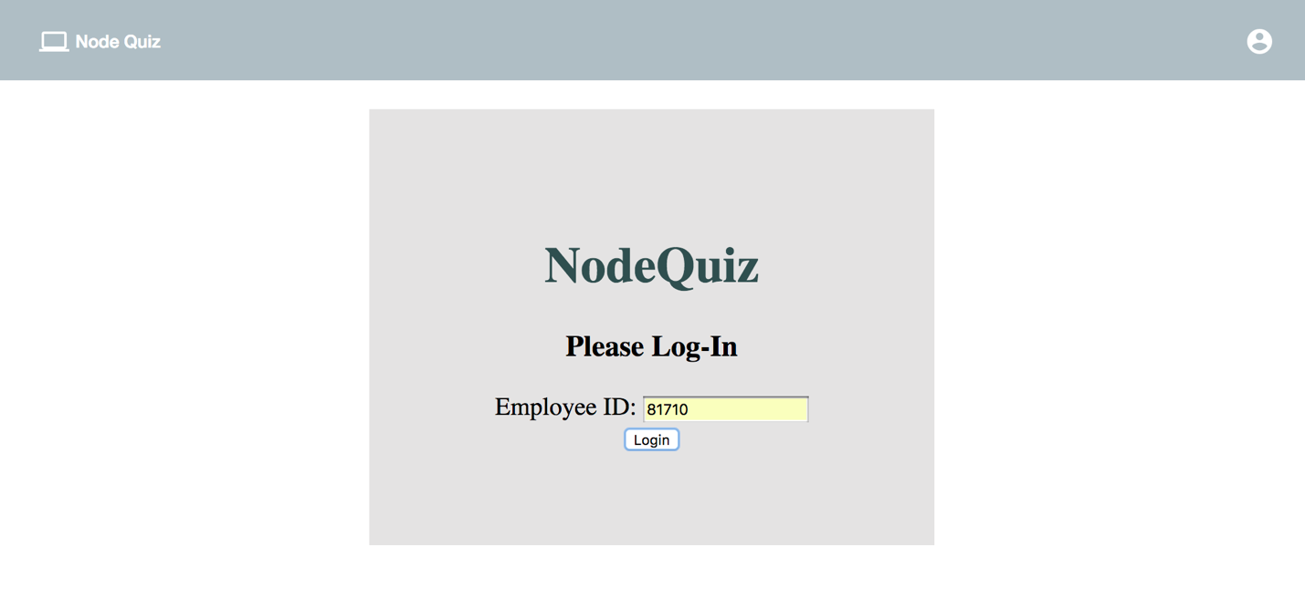

**PRESENTATION PAGE**

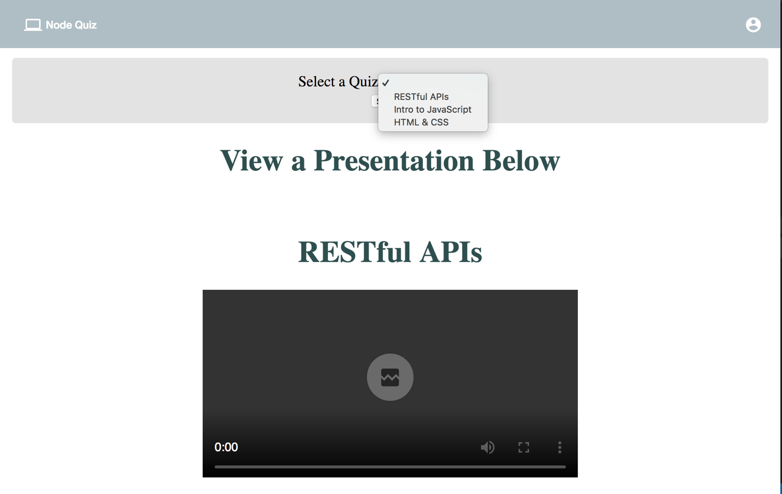

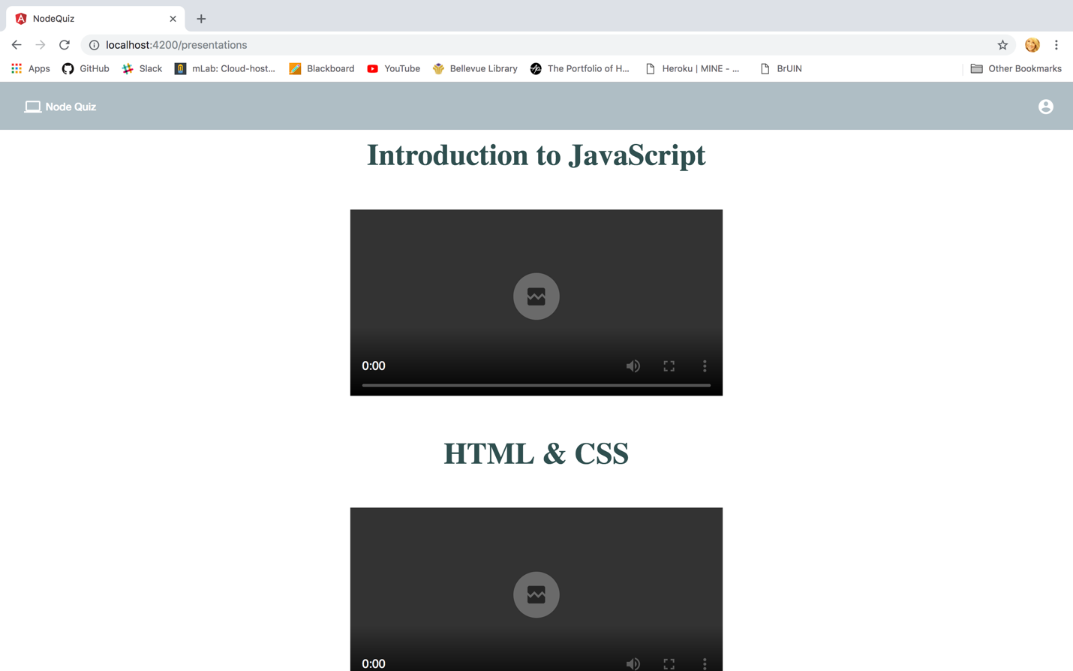

**QUIZ PAGE**

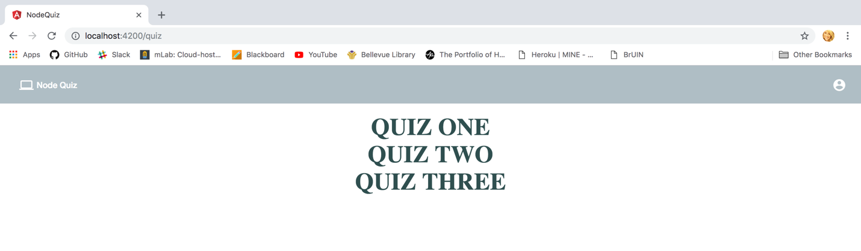

**RESULTS PAGE**

